Lab 06: Decision Tree and ANN Architecture
Learning Objectives
- Decision Tree.
- Decision Tree for Classification.
- Decision Tree for Regression.
- Problem of Overfitting.
- Difference Between ANN and Classical ML Algorithms

- Decision Tree
Decision Trees (DTs) are supervised learning method used for classification and regression. The goal is to create a model that predicts the value of a target variable by learning simple decision rules inferred from the data features. A tree can be seen as a piecewise constant approximation.
Decision tree learning employs a divide and conquer strategy by conducting a greedy search to identify the optimal split points within a tree. This process of splitting is then repeated in a top-down, recursive manner until all, or the majority of records have been classified under specific class labels.
To construct a decision tree, start by specifying a feature that will become the root node. Typically, no single feature can perfectly predict the final classes; this is called impurity. Methods such as Gini, entropy, and information gain are used to measure this impurity and identify how well a feature classifies the given data. The feature with the least impurity is selected as the node at any level.

- Classification
Decision Tree Classifier is a class capable of performing multi-class classification on a dataset. As with other classifiers, DecisionTreeClassifier takes as input two arrays: an array X, sparse or dense, of shape (n_samples, n_features) holding the training samples, and an array Y of integer values, shape (n_samples,), holding the class labels for the training samples.

  - Pseudo Code
- Load the e.g iris dataset.
- Split dataset into train and test set of ratio 80 and 20 respectively.
- Import decision tree classifier from sklearn: from sklearn.tree import DecisionTreeClassifier
- Prepare the decision tree classifier with default parameters.
- One model is trained, you can plot decision tree: tree.plot_tree(model)

  - Output
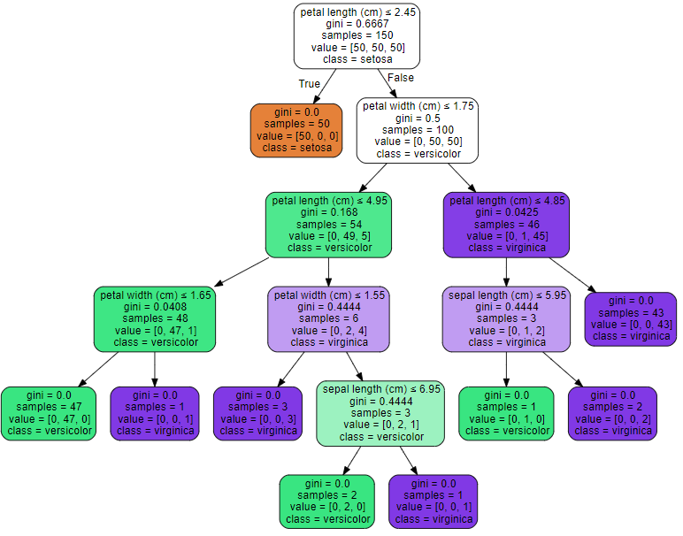

- Regression
In statistical modeling, regression analysis is a set of statistical processes for estimating the relationships between a dependent variable (often called the 'outcome' or 'response' variable, or a 'label' in machine learning parlance) and one or more independent variables (often called 'predictors', 'covariates', 'explanatory variables' or 'features').

  - Pseudo Code
- Load the dataset.
- Prepare the dataset: Sperate the load dataset into dependent and independent variables.
- Split the dataset into train and test set of raito 80% and 20% respectiveily.
- Import decision tree regressor from sklearn: from sklearn.tree import DecisionTreeRegressor
- Prepare the decision tree classifier with default parameters.
- Fit the model with reshaped train dataset.
- Predict the model with reshaped test dataset.
- Plot the decision tree regressor results

Lab Tasks
- Apply Decision Tree Classifier on the Customer Churn prediction dataset.
- Apply Decision Tree Regressor on the Car Price prediction dataset.
- Go through the attached Colab Notebook.
- Load the MNIST dataset and normalize the pixel values to the range 0-1.
- Reshape the 28x28 images into a 1D vector of size 784 for ANN compatibility.
- Build a simple ANN model with:
  - An input layer with 784 neurons.
  - One hidden layer with 128 neurons and ReLU activation.
  - An output layer with 10 neurons and softmax activation.
- Compile the model using the Adam optimizer, sparse categorical crossentropy as the loss function, and accuracy as a metric.
- Train the model on the training data for 10 epochs with a batch size of 32.
- Evaluate the model on the test dataset and report the test accuracy.
- Use the trained model to predict the classes for 5 random test samples and display the images with their predicted and actual labels.
- Calculate precision, recall, and F1-score for each class using the test dataset and include these metrics in the evaluation report.
- Save the trained model to a file and reload it for predictions on new data.

Lab # 06 Marks distribution

 | ER1 | ER5 | ER8
Task | 3 points | 3 points | 4 points

Lab # 06 Rubric Evaluation Guideline:
# | Qualities & Criteria | 0 < Poor <= 1 | 1 < Satisfactory <= 2 | 2 < Excellent <=3
ER1 | Task Completion | Minimal or no program functionality was achieved. | Some tasks were completed, but the program has errors or incomplete functionalities. | All tasks were completed, and the program runs without errors.
# | Qualities & Criteria | 0 < Poor <= 1 | 1 < Satisfactory <= 2 | 2 < Excellent <=3
ER5 | Analysis of Results | No attempt to analyze or interpret the results | Some analysis of the results is attempted, but explanations may be unclear or incomplete. | Results are correctly analyzed and compared to expectations, with clear explanations.
# | Qualities & Criteria | 0 < Poor <= 1 | 1.5 < Satisfactory <= 2.5 | 2.5 < Excellent <= 4
ER8 | Question & Answer | Answers some questions but not confidently or based on lab task knowledge. | Answers most questions confidently and based on lab task knowledge. | Answers all questions confidently and demonstrates a deep understanding of the given lab task.

